Installing the Bear Altimeter Console Android application.

The application will allow you to configure your altimeter and read the flights while you are on the field.

The application can be installed on pretty much any Android device starting from version 4.x of the Android OS.

In order to manually install it you will need a PC and a micro USB cable to connect it to your Android device.

**Step 1** – Plugin your Android device to one of your USB port.

Make sure that the device is on

On your PC a screen similar to the one below will appear

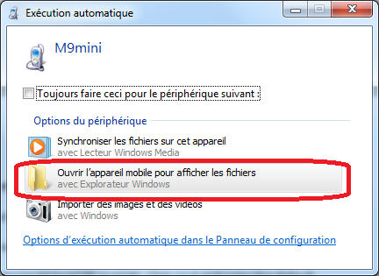

**Step 2** – In your file manager locate the SDCard of your device

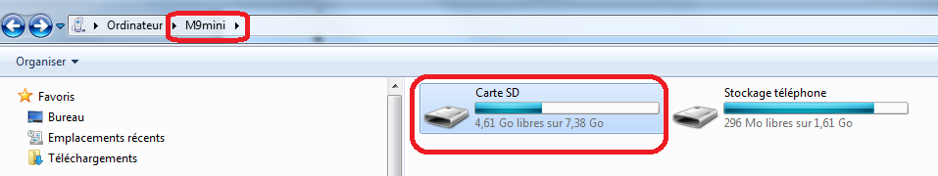

Click on the SDcard and copy the **bear-console.apk** file on the root of your SDCard

**Step 3** – Go to your Android device and look for a file manager

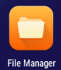

**Step 4** – Open up your file manager

Click on the SDCard

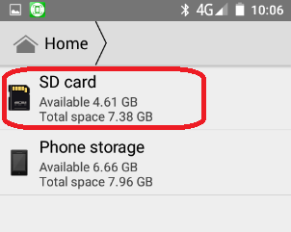

and search for the **bear-console.apk** file. Then double-click on it and install it.

**Step 5** – turn on the altimeter

Make sure that the Bluetooth module is connected. Wait for the altimeter to initialize.

Note that on some Bluetooth devices such as the HC-06 a red light should be flashing until it is connected.

**Step 6** – Pairing the Bluetooth device

You need to go the Android device **settings**,

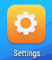

and go to the **Bluetooth** section.

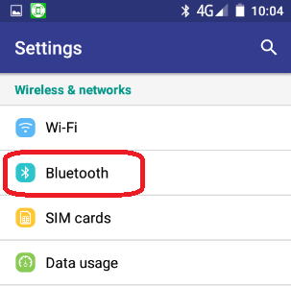

Make sure that Bluetooth is enabled and search for Bluetooth devices and the altimeter devices will appear.

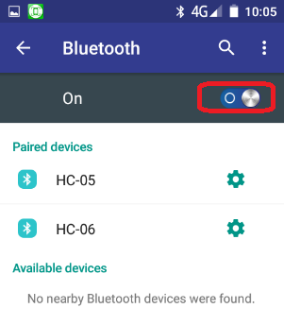

The module name used by the altimeter could be HC05 or HC06. Click on it and enter the default pairing code which is **1234**.

Use the Application

**Step 7** – Start the application

Locate the **Bear console** application icon and start it.

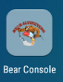

The application might prompt you to enable Bluetooth if it is off.

The following screen should open

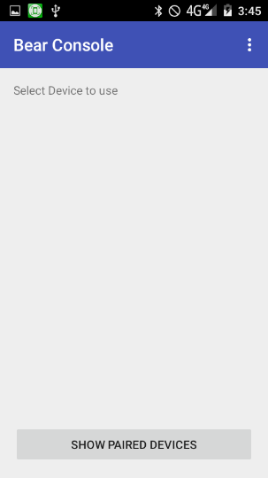

Note that from the menu you should be able to access the online help.

**Step 8** – connect to the altimeter

Click on 

And all your Bluetooth devices should list

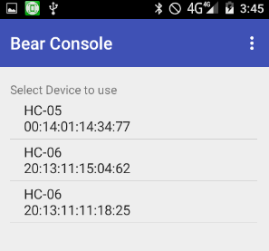

Click on the device used by the altimeter.

The application will attempt to connect and if it manages to do it you will get a Connected message.

You should now be connected to the console

**Screen navigation**

**Main screen**

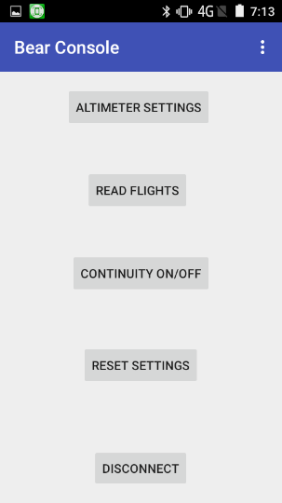

**ALTIMETER SETTINGS**



On this screen you can modify the altimeter configuration. Be sure you know what you are doing when changing the altimeter configuration. It is good practice when doing complex configuration to test the altimeter in a chamber before attempting any flight.

|  |  |
| --- | --- |
|  | **Units**: let you change the altimeter units  **Beep mode**: change the way the altimeter will beep the altitude  **Beep frequency**: Allow to change the frequency of the beep  **Main altitude**: This is the main parachute deployment altitude.  **Output 1, 2 and 3**: Assign a function to each output. This can be a main, drogue; timer or the output can be disabled. Note that you can have one main and one drogue max but from zero up to 3 timers.  **Delay 1, 2 and 3**: Each output has a delay associated. If the output is a main or a drogue this will delay the main or drogue. Drogue is trigger at apogee and main is triggered X meters before landing. Do not forget to set the main altitude.  If the output is a timer it is the number of ms after liftoff that will trigger the timer. Note that if the timer occurs after landing it will not be triggered.  When you have finished click on [UPLOAD]. Before uploading it will check for potential errors and cancel any bad configuration saving. |

**READ FLIGHT**



This will retrieve all the flights that have been stored in your altimeter if any. This might take a long time to retrieve all the flight data.

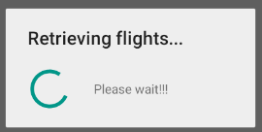

When you have the flight list just click on each flight to display the flight data.

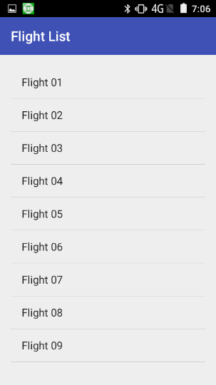

Note that the altimeter can record up to 25 flights off data. However it could be less depending on the amount of data (ie: each flight duration).

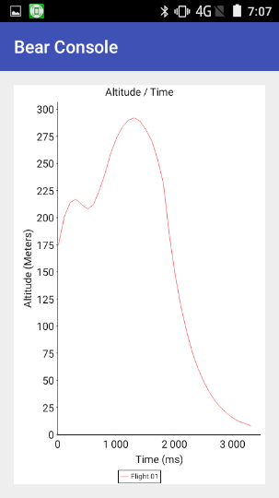

**CONTINUITY ON/OFF**



Turn on or off the continuity. This can be really annoying to setup an altimeter that is continuously beeping. So one tap will turn the beeps off and a second tap will turn it on.

**RESET SETTINGS**



**This open the Reset Settings screen.** Clear the flight list and allow resetting the altimeter setting to factory default.

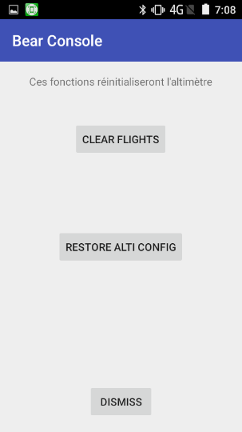

|  |  |
| --- | --- |
|  | Note that it will clear all flight data. |
|  | Should need to re-initialize your altimeter this is where you want to go. |

**DISCONNECT**



This allows you to disconnect from the altimeter.

**Main screen menu**

From the main screen menu you can access the online help, an about screen and the application settings.

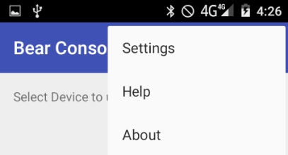

**Application preferences screen**

|  |  |
| --- | --- |
|  | This is mainly to setup the look and feel of the application to accommodate to the Android device that you are using.  On the settings screen you can choose the **application language**  The **color for the graph** and the **background color**  The **unit** used by the application (ie: metric or imperial)  You can also change the **font size**. |

**Help Screen**

|  |  |
| --- | --- |
|  | This is a quick on line help which can be used on the field |

**About Screen**

|  |  |
| --- | --- |
|  |  |

**About Screen**

|  |  |
| --- | --- |
|  | Just an about screen to give me credit and display the version of the Altimeter Console |